
  - Faculty of Aviation and Transportation

Final Report for topic Web and Mobile Applications

Title: Math’s Coffee

Demierre Mathieu 141WMA2

1. Introduction: The Vision
For this project, I chose to move beyond a simple café and wanted to create Math’s Coffee with an inspiration of New York, a city I really like and that on my opinion has the best coffee spots. My inspiration comes from a real coffee place I visited in Brooklyn. My vision was a high-end coffee shop located in Williamsburg, Brooklyn, designed to represent a mix of the soulful, artistic atmosphere of New York but also to let the vibrant part of the city be part of it.

2. Week-by-Week Development
Week 01: Foundations & UX Design
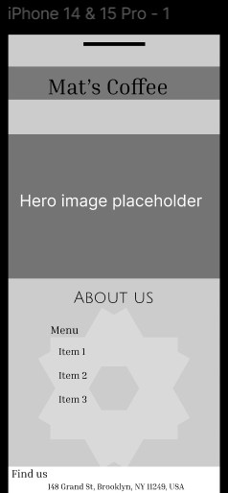
Using Figma, I created a mobile wireframe focusing on a clean vertical layout. I ensured that the most important navigation elements were easy to reach on an iPhone screen, setting the stage for the Header, Hero, and Menu sections.

Week 02: The Skeleton (HTML5)
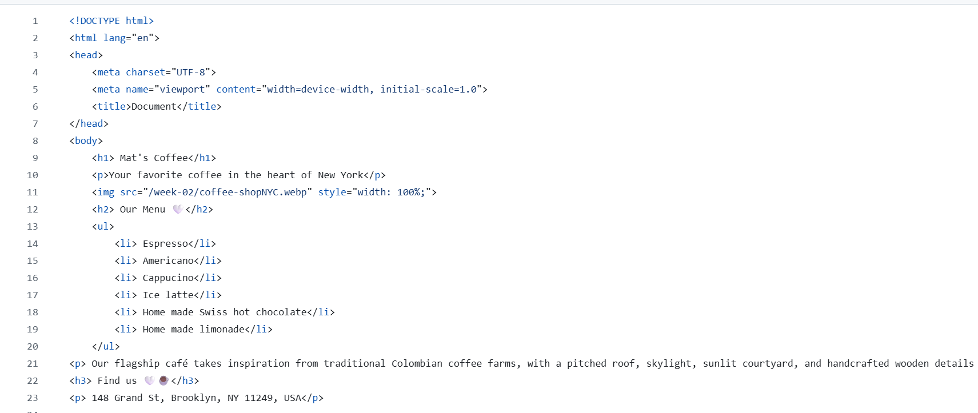
I translated my visual Figma design into a structured document. I learned how to use Semantic HTML5 tags (like <header>, <section>, and <footer>) to build a solid skeleton. This was my first step in making the site "readable" for both humans and search engine bots.

Week 03: The Skin (Mobile-First CSS)
I turned the black-and-white skeleton into a branded page using CSS. I applied Mobile-First rules to ensure the site was compatible to use on mobiles. I also learned to use CSS variables for my brand colors to keep the design consistent and easy to update.
Week 04: CMS & Security Setup
I migrated the project to WordPress using Pantheon (our hosting platform). This week I installed Wordfence for security and WPS Hide Login to protect my dashboard. I also added the first pages of my website, renamed them and started the first designs. I also used SEO to optimize it for search engines.
Week 05: Data Strategy & GDPR
I transformed the site into a data-driven business. I installed Google Tag Manager (GTM) and GA4 to track user behaviour. Most importantly, I integrated a Cookie-Script banner to make sure the site was 100% GDPR compliant before any tracking began.
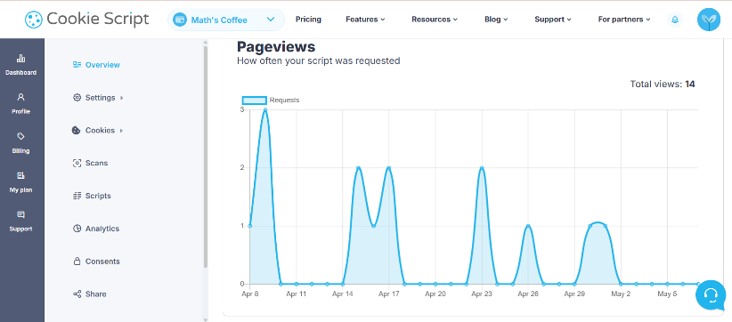
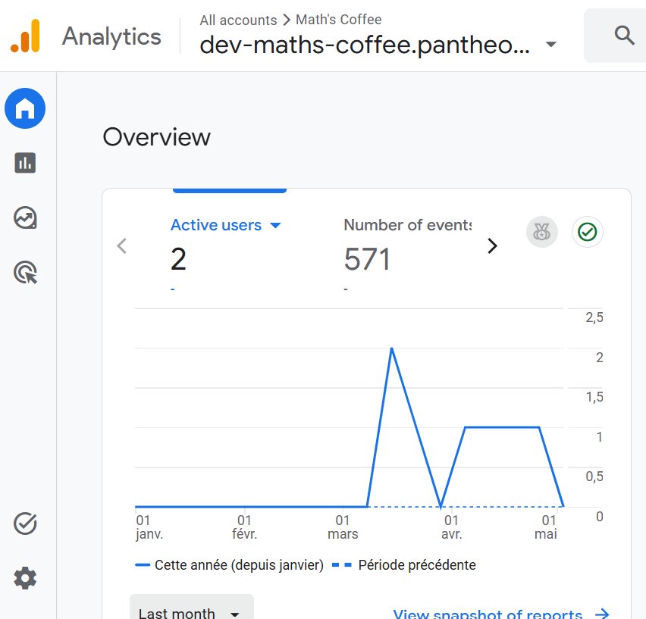
Week 06: AI-Augmented Design
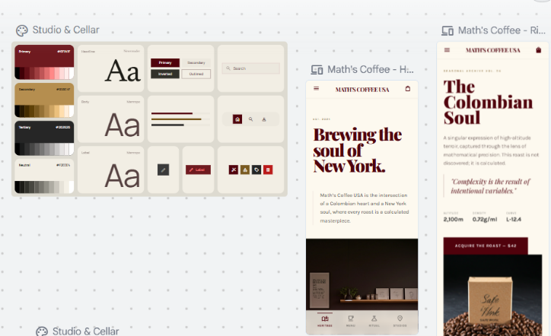
I used AI Prompt Engineering to level up the brand’s look which is Stitch. I asked Gemini to define my brand persona and used AI image generators to create professional storefront assets. I then manually updated my WordPress styles to match this high-end AI design. Stitch really helped me to create the vibe of the coffee shop I imagined so I inspired myself a lot from the colours and style

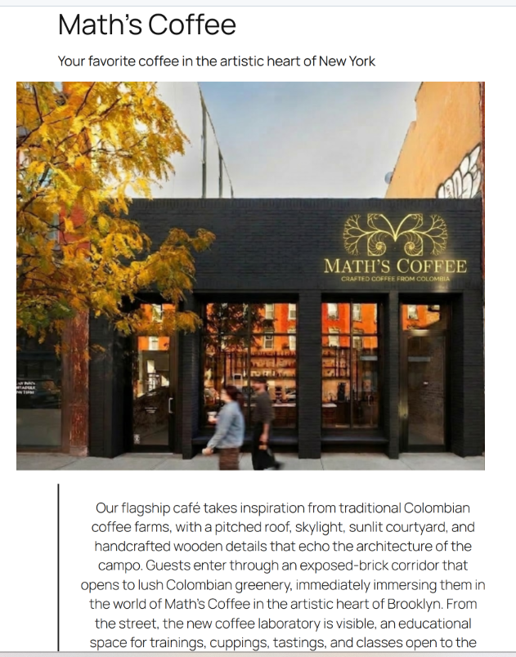
A before and after
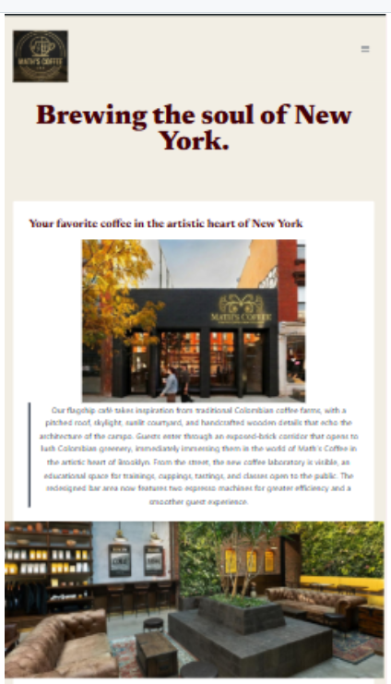

Week 07: Lead Generation & Performance
I created a "Value Exchange" by building a Loyalty Club form in WPForms. To make sure the site was fast, I ran a Lighthouse Audit. I found that my images were too heavy, so I converted them to WebP format, which significantly improved my mobile performance score.
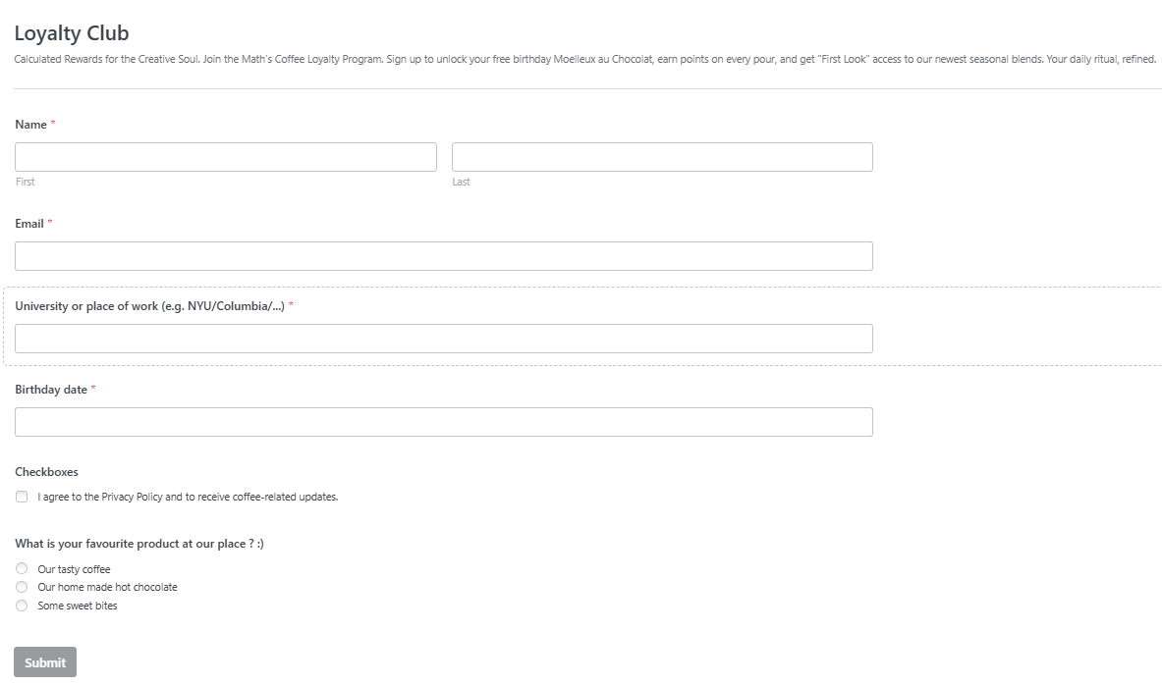

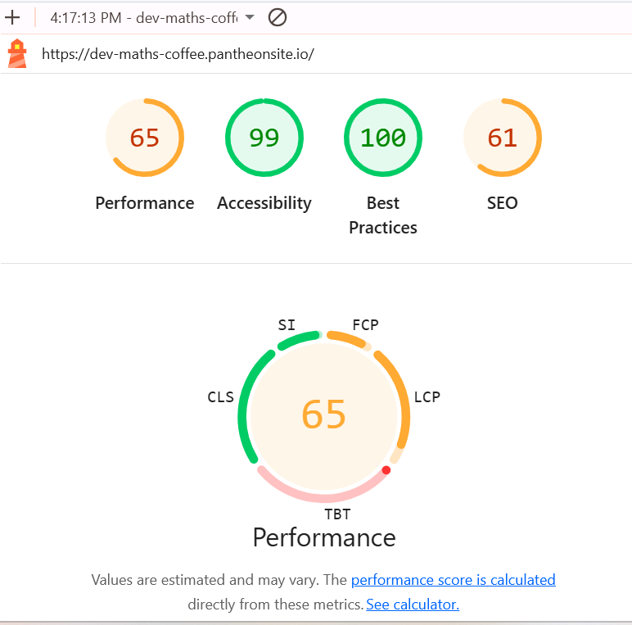

Week 08: Visibility (SEO & Social)
I focused on how the world sees my brand. Using RankMath, I optimized my Social tags so that sharing the link looks professional. I also checked my Sitemap to ensure Google could index all my pages correctly for search results.
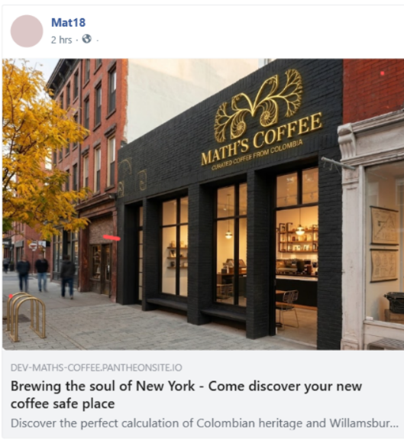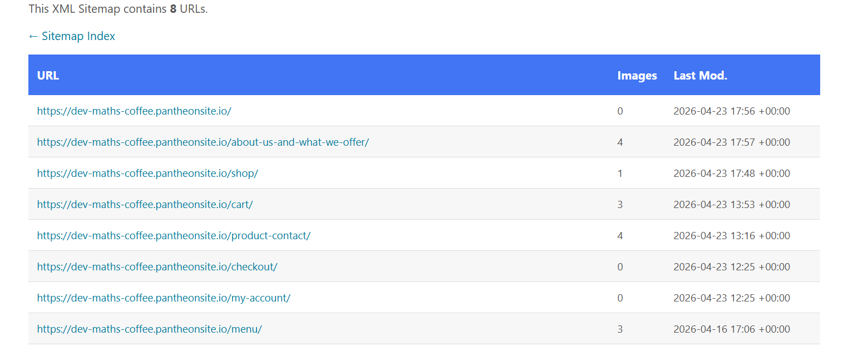
Week 09: Transactions (WooCommerce)
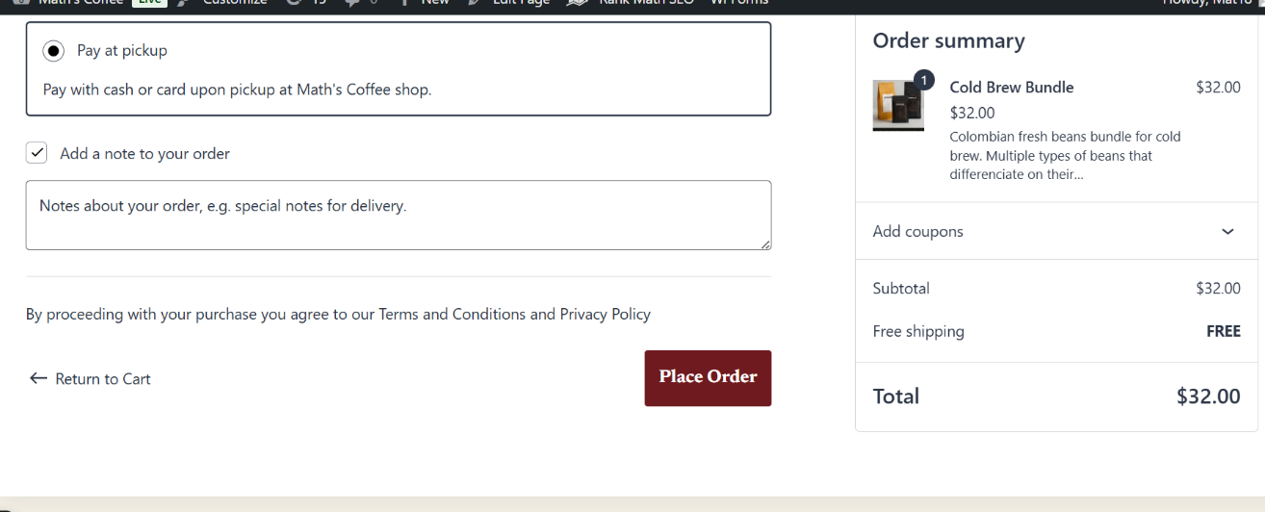
I transformed the site into a functional shop. I installed WooCommerce and created a digital menu. I learned how to set up Variable Products (like different types of bean strength) and tested the "Frictionless Checkout" with a "Pay at Counter" option.

Week 10: Retention & Automation
For the final week, I focused on loyalty. I created a NEWCOMERS 15% discount code and designed an automated Welcome Email. I added a "Favorite Product" survey to my forms to help me personalize future marketing. Finally, I secured everything with a full UpdraftPlus backup.
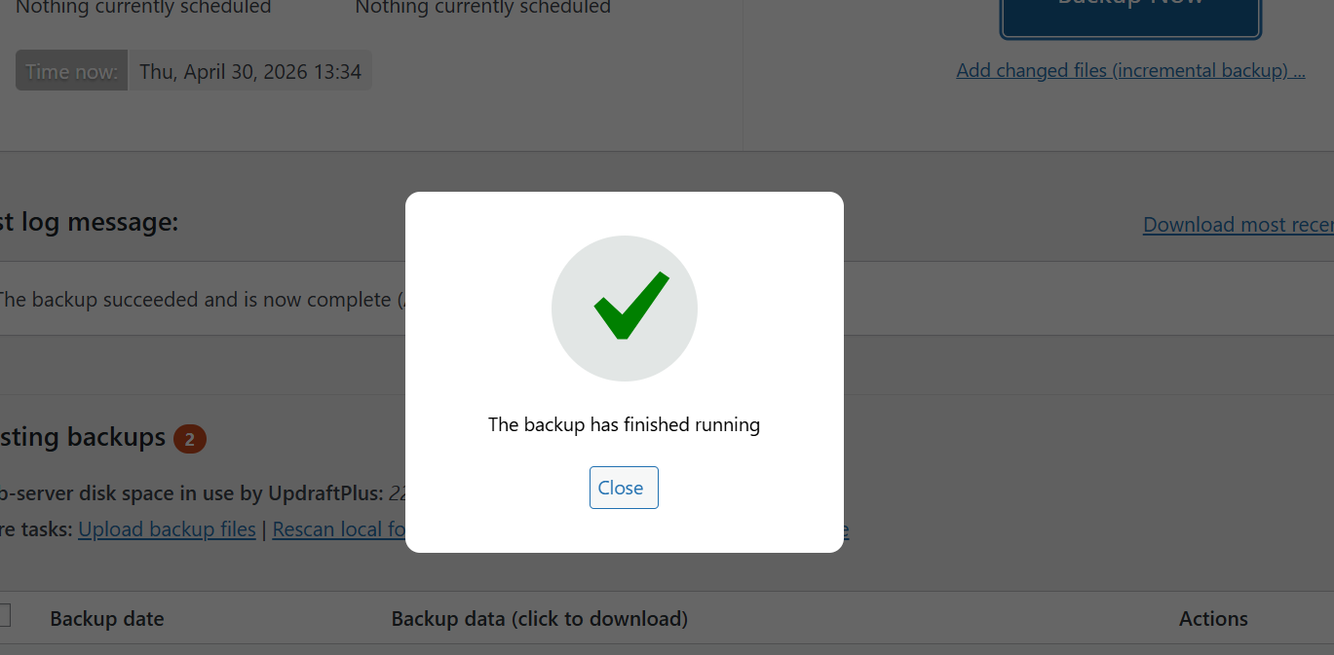

3. Conclusion
This project taught me a lot because I had no knowing about how to create a website or even design one. I found really interesting and satisfying having created something nice looking from zero. Now I have s website with a balance of design, security, data information. I learned that you cannot have a good business without a secure foundation and a way to talk back to your customers through automation. Using AI as a creative partner allowed me to create a professional brand in a very short amount of time, but it also helped to create something as I imagined it. I also enjoyed using

4. Suggestions
- AI Video/Music: I really enjoyed the AI week. In the future, maybe we could explore tools for AI-generated background music or short video clips for the Hero sections.

